Project Description – Find A Pump

Overview and Justification
Find a Pump is a web-based application that strives to help users find the gas station with the cheapest gas near them in Utah county. To help users find a pump that fits their needs, they will be able to filter the results by type of gas (diesel or regular), quality, or even find an EV charger. Users will be able to add in any discounts they receive at specific gas stations to be factored in automatically for them. They will also be able to modify the search area, which will allow them to choose how far they are willing to go for the cheapest gas.
Find a Pump aims to alleviate the pain points of constantly fluctuating gas prices and the current inflation problem by providing users with the latest price information available. This will take the stress out of spending too much money on gas and remove the uncertainty of what the price will be. Utah county is full of college-aged adults who typically have tight budgets and do not have the ability to spend frivolously. Providing them with the cheapest gas options will allow them to enjoy their time and use their money where it matters more fully.

Tech Stack and Measuring Success

The application will integrate Google Maps APIs to provide accurate geolocation and redirect Google Maps to get turn by turn direction. A responsive frontend with React will display station distance and current fuel or charging prices. The backend, powered by Node.js with Express, will manage API requests, data aggregation, and communication with external APIs. A local SQLite database will store station metadata, user preferences, and cached results to improve performance. Then for the data processing the application will use JavaScript for the caching and aggregation. Together, this tech stack creates a scalable, intuitive, and reliable application that enhances everyday travel planning.

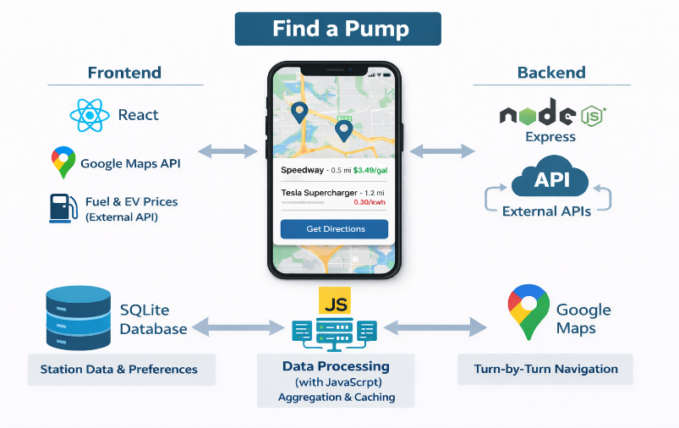

The application is complete once it has met its core functionality goals, reliably retrieving and displaying nearby stations with accurate distance and pricing information. Verifying that the Google Maps redirection works consistently, ensuring seamless navigation for users. From a UI/UX perspective, the interface is clean, responsive, and intuitive, while map interactions such as zooming, panning, and marker selection feel natural. If launched, the shipped version will demonstrate powerful performance, with average API response times under five hundred milliseconds and map and station data loading within two seconds. The user engagement metrics should indicate healthy adoption, reflected in steady daily active users and frequent station lookups per session. Lastly, in terms of reliability, the application maintains 99% uptime over a 7-day period, with API error rates kept below 5%.

API Research
To power our app, it will need live accurate price data for the different fuel types at gas stations across Utah County. The best way to do this is to use an existing API which hosts this live data already. One example of an API the application could use is like the one hosted at “www.oilpriceapi.com” which can give the real-time prices of fuel at each station filtered by latitude and longitude coordinate with a radius around it. This data will include the prices of the fuel at each station for us to use to display and sort.
To get accurate live data of these prices, when the user opens the app, it will get data from the API. That can store it in the app database to display prices on the map. If a user launches the app again offline or if the API is down, it will use the existing prices in the database to continue to display information. Storing the data from the API in our own database will limit the number of times the API is called, as well as give us more flexibility for querying and displaying the data.
Google Maps API is what will power the geospatial mapping portion of the application. It allows us to use JavaScript to create a live map pulling from Google Maps, then be able to add man pins/markers on the map as needed. This streamlines the process, so all that will need to be done is implement it is to create an API in our backend to query each of the station’s coordinates and prices, then iterate through them placing them on the map.

Potential Features and Stakeholders
This application is designed to help consumers in Utah County quickly locate nearby gas stations and compare fuel prices in their area. Using the user’s current location, the system will display gas stations on an interactive map or in a list-based view, allowing users to easily identify both the closest and the cheapest options available. Key features include location-based search, fuel price displays for multiple fuel types, distance indicators showing how far each station is from the user, and sorting or filtering options that allow users to prioritize proximity or cost. These features are intended to save users time, reduce fuel expenses, and simplify the decision-making process when choosing where to refuel.
The primary stakeholders of this system are drivers in Utah County who directly benefit from easy access to nearby gas station locations and fuel price comparisons. Secondary stakeholders include gas station owners, who may experience increased visibility and customer traffic when their stations appear competitive options within the application, as well as third-party API and data providers that supply the location and pricing information used by the system. Indirect stakeholders include members of the local community, who may benefit from reduced unnecessary driving, and the development team. Those who are responsible for ensuring the system remain dependable, accurate, and user-friendly.

